ESG Factsheet 2025
Weyland Energy – key sustainability figures
Noah Fischer · 09 April 2026
We develop, build and operate wind, solar and storage assets that deliver affordable clean power to communities across Northern Europe. In 2025 our assets generated 2,860 GWh of renewable electricity and avoided 1.2 million tonnes of CO₂.
KPI | Unit | 2024 | 2025
Renewable generation | GWh | 2,664.0 | 2,860.0
CO₂ emissions avoided | Mt CO₂e | 1.08 | 1.2
Scope 1 emissions | t CO₂e | 1,960 | 1,840
Scope 2 emissions (market-based) | t CO₂e | 3,110 | 2,960
Scope 3 emissions | t CO₂e | 286,000 | 412,000
Employees (31 Dec) | headcount | 418 | 450
Women in workforce | % | 33 | 34
Women in leadership positions | % | 27 | 31
Total recordable injury rate (TRIR) | per million hours | 2.4 | 2.1
Lost time injury frequency (LTIF) | per million hours | 1.1 | 0.9
Community benefit funds paid | EUR k | 610 | 745
Taxonomy-aligned revenue | % | 95 | 96
Taxonomy-aligned capex | % | 98 | 99

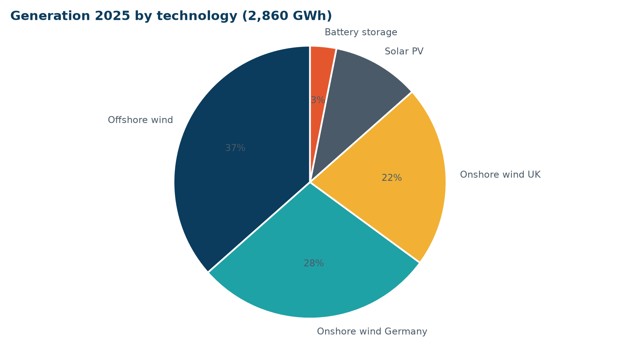
Generation 2025 by technology

Our commitments
- Net zero in our own operations (scope 1 and 2) by 2030
- Science-based scope 3 target to be submitted in 2027
- 20 % biodiversity net gain on all new onshore projects
- 40 % women in leadership by 2030

